
Get Out the Vote Toolkit for ECE Providers
Access to voting is an equity issue. Children cannot vote and rely on adults to participate in electing lawmakers who will fight for their well-being.
Early Childhood Education programs have power in supporting families and staff registering to vote, learning about candidate issues, and getting to the polls (or drop box) on Election Day. Here are some resources and activities you can take part in to Get Out the Vote!
For your program:
- Share GOTV resources with staff and families in an advocacy display
  - Request a customized display kit for your program: Advocacy Display Kit (google.com)
- Know important election dates and deadlines (page 2)
- Print voter registration signs (pages 5-6)
- Consider extending program hours on Election Day until 9pm
  - Contact Publicpolicy@firstup.org if your program will offer extended hours
For children:
- Facilitate voting activities with children
  - Let's Vote! Talking to Children About Voting | PBS KIDS for Parents
  - Preschoolers can vote - preschool voting activities (thingstoshareandremember.com)
  - Election and Voting Activities for Kids - (teachersbrain.com)
- Books about voting (see pages 3-4 for additional titles)
  - 26 Children's Books about Elections and Voting - Imagination Soup
  - 25 Children's Books That Teach Kids About Elections And Voting | HuffPost Life
Voting information:
- General PA Voting Information to share with families & staff: https://www.vote.pa.gov/
- Information for first-time voters: First Time Voters
- Learn who is on your ballot: Committee of 70 Voter Guide (seventy.org)
- Mail in Ballot information https://vote.pa/info/mail/
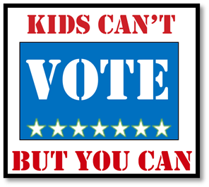

ECE Community: Let’s Get Out the Vote!
FALL 2025 ELECTION SEASON CALENDAR
MONDAY  September 22 | MONDAY  October 6 | MONDAY  October 20 | TUESDAY  October 28 | MONDAY  November 3 | TUESDAY  November 4
Four weeks left to register to vote on Election Day.  ~ Post registration forms at your program.  ~ Talk with staff/colleagues about getting out the vote.  ~ Implement GOTV activities with children to build excitement. | Two weeks left to register to vote.  ~ Set up a “Five Minute Table" in your program and ask all your parents if they are registered.  ~ Send home registration forms with all families and post links on your website or social media accounts.  ~ Remind families about absentee ballots and how to apply for them.  Visit https://vote.pa.gov for voter registration info. | Last day for voter registration deadline.  ~ Check in with unregistered staff/colleagues who have talked about registering.  ~ Ask staff to remind parents about registering in the morning when they bring their children in.  ~ Begin planning for extended hours on Election Day until 9pm. | Last day to apply for a mail-in or absentee ballot.  ~ Prepare to send home a Halloween or harvest goody bag with each child.  ~ Include a flyer from First Up inviting parents to educate themselves about voting in PA Elections.  ~ Remind parents about your extended Election Day coverage.  For candidate info, visit https://ballot.seventy.org. | Election Day Eve  ~ Put a big poster up on your door reminding parents of election hours.  ~ Make final arrangements for Election Day coverage that will allow all parents and staff to vote.  ~ Provide staff/parents with Get Out the Vote stickers to wear on Election Day - get printable stickers at https://www.firstup.org | Election Day  ~ Implement your coverage plan.  ~ Have beverages & snacks available.  ~ Encourage everyone to wear a GOTV sticker.  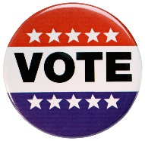

Children’s Books About Voting

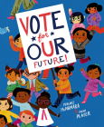

Vote for Our Future! (Hardcover)
By Margaret McNamara, Micah Player (Illustrator)

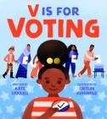

V Is for Voting (Hardcover)
By Kate Farrell, Caitlin Kuhwald (Illustrator)

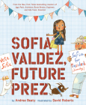
Sofia Valdez, Future Prez (The Questioneers) (Hardcover)
By Andrea Beaty, David Roberts (Illustrator)

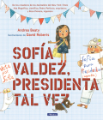
Sofía Valdez, presidenta tal vez / Sofia Valdez, Future Prez (Los Preguntones / The Questioneers) (Hardcover)
By Andrea Beaty

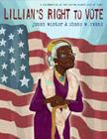

Lillian's Right to Vote: A Celebration of the Voting Rights Act of 1965 (Hardcover)
By Jonah Winter, Shane W. Evans (Illustrator)

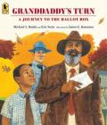Granddaddy's Turn: A Journey to the Ballot Box (Paperback)
By Michael S. Bandy, Eric Stein, James E. Ransome (Illustrator)

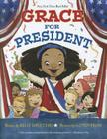

Grace for President (Grace Series #1) (Hardcover)
By Kelly DiPucchio, LeUyen Pham (Illustrator)

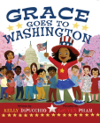Grace Goes to Washington (Grace Series #2) (Hardcover)
By Kelly DiPucchio, LeUyen Pham (Illustrator)

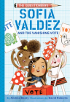
Sofia Valdez and the Vanishing Vote: The Questioneers Book #4 (Hardcover)
By Andrea Beaty, David Roberts (Illustrator)

Voting books on video
Vote for our Future Read Aloud- https://www.youtube.com/watch?v=AGpG2qhtZZE
Lillian's Right to Vote- Lillian's Right to Vote - Read Aloud Picture Book | Brightly Storytime (youtube.com)
Grace for President by Kelly DiPucchio- Grace for President by Kelly DiPucchio | Read-Aloud Children's Book about the Election Process (youtube.com)
Sesame Street: Election Day- https://www.youtube.com/watch?v=LRw4iuq498Y
Mini’s First Vote - https://www.youtube.com/watch?v=dfpx2PXWJwI

Register to Vote!!
Election Day is November 4
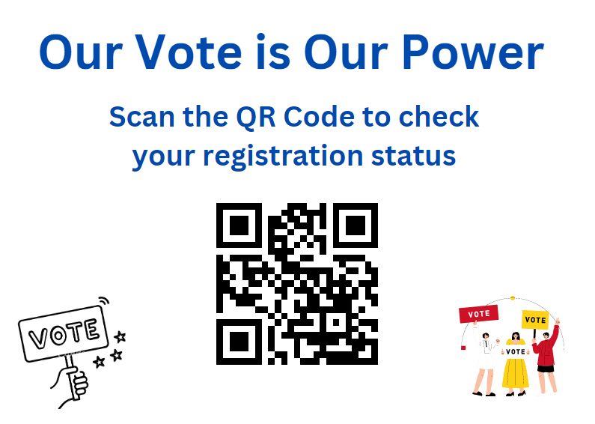
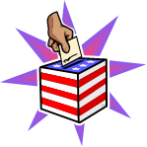

¡¡ Registrase para Votar!!
El día de las elecciones es el 4 de noviembre
